### 4.4 Lampiran Hasil Uji Coba

### 4.4.1 Hasil Uji Coba

Table 42 Skenario Uji Coba

|  |  |  |
| --- | --- | --- |
| **Ujicoba** | **Trainig** | **Testing** |
| 1 | 250 DATA | 250 DATA |
| 2 | 500 DATA | 500 DATA |
| 3 | 1000 DATA | 500 DATA |

#### Skenario 1

Table 43 Data training dan data testing skenario 1

|  |  |  |
| --- | --- | --- |
| **Ujicoba** | **Trainig** | **Testing** |
| 1 | 250 DATA | 250 DATA |

Table 44 Perubahan Uji Coba dengan perubahan nilai epoch pada data

|  |  |  |  |  |
| --- | --- | --- | --- | --- |
| **Epoch** | **Learning Rate** | **MSE** | **MAPE %** | **Akurasi %** |
| 25 | 0.2 | 978.08 | 27.28 | 72.72 |
| 50 | 0.2 | 411.52 | 17.89 | 82.11 |
| 100 | 0.2 | 5.51 | 1.85 | 98.15 |
| 200 | 0.2 | 169.28 | 10.05 | 89.95 |
| 400 | 0.2 | 261.98 | 12.50 | 87.5 |

|  |  |  |  |  |
| --- | --- | --- | --- | --- |
| **Epoch** | **Learning Rate** | **MSE** | **MAPE %** | **Akurasi %** |
| 100 | 0.05 | 1038.40 | 27.74 | 72.26 |
| 100 | 0.1 | 474.09 | 19.06 | 80.94 |
| 100 | 0.2 | 5.51 | 1.85 | 98.15 |
| 100 | 0.3 | 37.64 | 4.46 | 95.53 |
| 100 | 0.4 | 50.47 | 5.13 | 94.87 |

Table 45 Perubahan Uji Coba dengan perubahan nilai Learning rate pada data

Table 46 Hasil terbaik Skenario 1

|  |  |  |  |  |
| --- | --- | --- | --- | --- |
| **Epoch** | **Learning Rate** | **MSE** | **MAPE %** | **Akurasi %** |
| 100 | 0.2 | 5.51 | 1.85 | 98.15 |

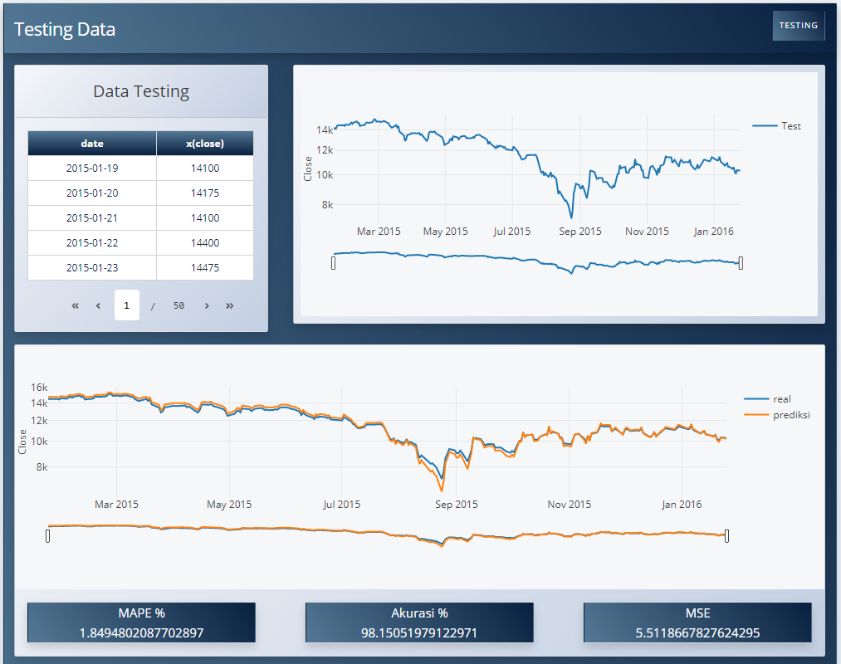Gambar 4.28 Tampilan hasil testing data scenario 1 terbaik

#### Skenario 2

Table 47 Data training dan data testing skenario 2

|  |  |  |
| --- | --- | --- |
| **Ujicoba** | **Trainig** | **Testing** |
| 1 | 500 DATA | 500 DATA |

Table 48 Perubahan Uji Coba dengan perubahan nilai epoch pada data

|  |  |  |  |  |
| --- | --- | --- | --- | --- |
| **Epoch** | **Learning Rate** | **MSE** | **MAPE %** | **Akurasi %** |
| 25 | 0.2 | 3.60 | 1.88 | 98.12 |
| 50 | 0.2 | 2.28 | 1.26 | 98.74 |
| 100 | 0.2 | 1.73 | 1.10 | 98.90 |
| 200 | 0.2 | 0.50 | 0.60 | 99.40 |
| 400 | 0.2 | 0.11 | 0.30 | 99.72 |

Table 49 PerubahanUji Coba dengan perubahan nilai Learning rate pada data

|  |  |  |  |  |
| --- | --- | --- | --- | --- |
| **Epoch** | **Learning Rate** | **MSE** | **MAPE %** | **Akurasi %** |
| 400 | 0.05 | 1.165 | 0.90 | 99.10 |
| 400 | 0.1 | 0.82 | 0.74 | 99.26 |
| 400 | 0.2 | 0.11 | 0.30 | 99.72 |
| 400 | 0.3 | 0.44 | 0.49 | 99.51 |
| 400 | 0.4 | 0.63 | 0.60 | 99.40 |

Table 50 Hasil terbaik Skenario 1

|  |  |  |  |  |
| --- | --- | --- | --- | --- |
| **Epoch** | **Learning Rate** | **MSE** | **MAPE %** | **Akurasi %** |
| 400 | 0.2 | 0.11 | 0.30 | 99.72 |

Gambar 4.29. Tampilan hasil testing data scenario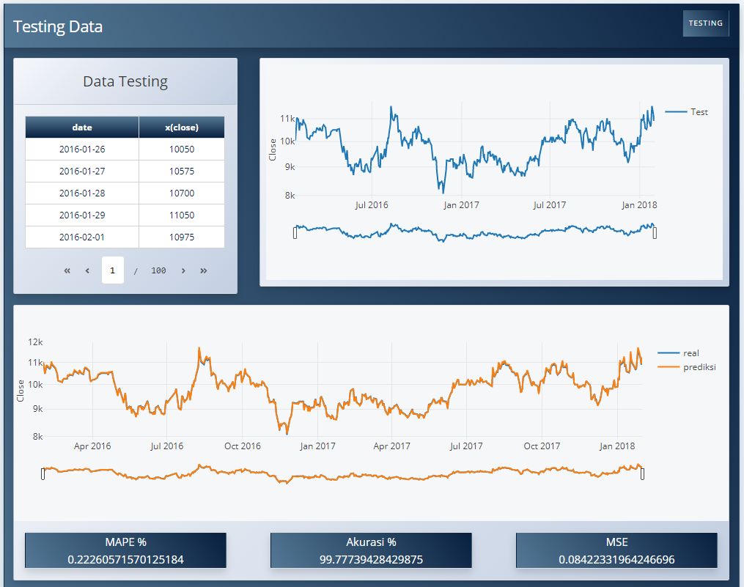 2 terbaik

#### Skenario 3

Table 51 Data training dan data testing skenario 3

|  |  |  |
| --- | --- | --- |
| **Ujicoba** | **Trainig** | **Testing** |
| 1 | 1000 DATA | 500 DATA |

Table 52 Perubahan Uji Coba dengan perubahan nilai Epoch pada data

|  |  |  |  |  |
| --- | --- | --- | --- | --- |
| **Epoch** | **Learning Rate** | **MSE** | **MAPE %** | **Akurasi %** |
| 25 | 0.2 | 6.00 | 1.87 | 98.13 |
| 50 | 0.2 | 0.51 | 0.38 | 99.62 |
| 100 | 0.2 | 0.87 | 0.61 | 99.40 |
| 200 | 0.2 | 1.81 | 0.88 | 99.16 |
| 400 | 0.2 | 1.94 | 0.87 | 99.13 |

Table 53 Perubahan Uji Coba dengan perubahan nilai Learning rate pada data

|  |  |  |  |  |
| --- | --- | --- | --- | --- |
| **Epoch** | **Learning Rate** | **MSE** | **MAPE %** | **Akurasi %** |
| 50 | 0.05 | 8.74 | 1.91 | 98.09 |
| 50 | 0.1 | 2.38 | 1.25 | 98.75 |
| 50 | 0.2 | 0.51 | 0.38 | 99.62 |
| 50 | 0.3 | 2.12 | 0.98 | 99.02 |
| 50 | 0.4 | 2.14 | 0.83 | 99.17 |

Table 54 Hasil terbaik Skenario 3

|  |  |  |  |  |
| --- | --- | --- | --- | --- |
| **Epoch** | **Learning Rate** | **MSE** | **MAPE %** | **Akurasi %** |
| 50 | 0.2 | 0.51 | 0.38 | 99.62 |

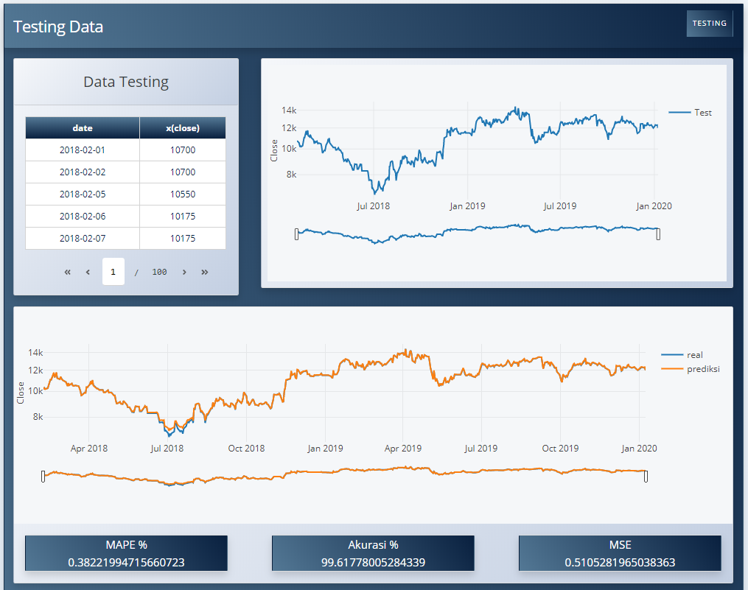

Gambar 4.10 Tampilan hasil testing data scenario 3 terbaik